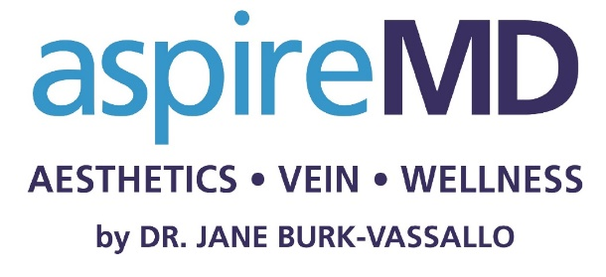
Aesthetic Interest Questionnaire | (Patient label)
Date:

What is the main reason for your visit today?
I would like to be advised on:

- How I can look better for my age

- How I can change something that
has been bothering me for years

- How I can look more attractive

- Other:

Have you had a consultation or treatment  for a cosmetic procedure before? |  | How often do you think about wanting  a cosmetic procedure?
- Yes | - No | - Most days | - Weekly | - Monthly

Which three statements  best reflect how you would  like to look and feel after  the treatment? | - I want to look less tired  - I want to look less angry  - I want to look less sad | - I want a less saggy appearance  - I want to look more youthful  - I want to look more attractive | - I want my face to look slimmer  - I want softer features
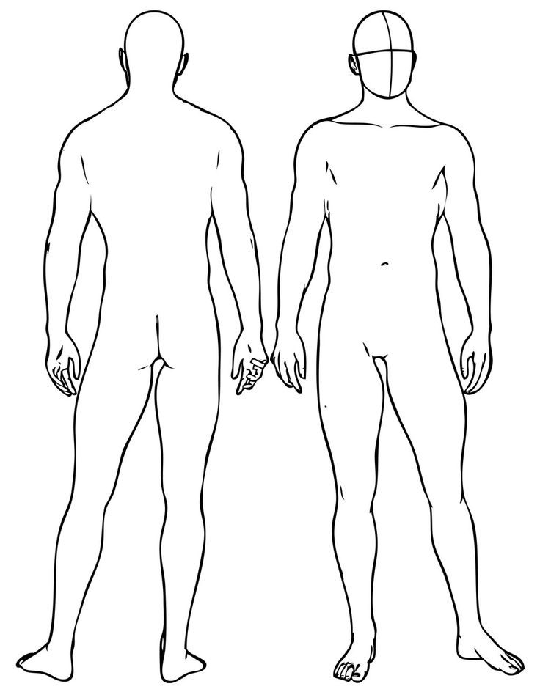
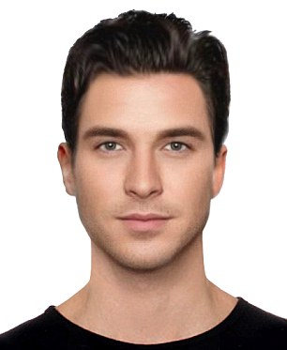
Please circle the area(s) of your interest:
How would you rate the quality of your skin?  (Please circle the appropriate answer) | Poor | Fair | Good | Very Good | Excellent

If you could enhance an aspect of your skin, what would you enhance?  (Please circle the appropriate answer) | Hydration | Elasticity | Smoothness | Colour

These treatments/products interest me:
(Please circle the treatment area(s) that interest you)

SKIN ENHANCEMENT | FACIAL IMPROVEMENT | BODY CONTOURING | OTHER
Skin injectables | Facial Fillers | Fat Reduction | Laser Hair Removal
Reduce Pigment  (Reds & Browns) | Wrinkle Relaxers | Reduce Cellulite | Bio-Identical Hormone Optimization
Tighten Loose Skin | Fat Reduction – Chin | Skin Tightening | Testosterone Replacement Therapy
Resurface Uneven Skin | Nose Correction |  | Moles, Lumps and Bumps  Ablation
Microneedling with PRP | Brow Correction |  | Microblading
Medical Peels |  |  | Hair Regain and Retain
SilkPeel |  |  | Snoring
Diminish Scars |  |  | Nail Fungus
Acne Program |  |  | Optimal Aging
Daily Skin Care

How did you hear about us? |  | Contact information
- My doctor  - My insurance company provider  - Advertisements  - A friend or family member | - Google  - Social media  - Event  - Other | - I would like to receive information about  new products/trends/your clinic  - You may contact me for further questions  concerning an appointment at your clinic

Phone number: _________________________________________________

E-mail address: _________________________________________________

Signature: _____________________________________________________

